**FLEET MANAGEMENT SYSTEM**

Login Screen

Url: <http://147.182.176.83/>

**Credentials:**

For admin  
Email admin@fleet.com  
Pass admin@00

For Clerk  
Email clerk@fleet.com  
Pass clerk@00

For Duty Station  
Email station@fleet.com  
Pass station@00

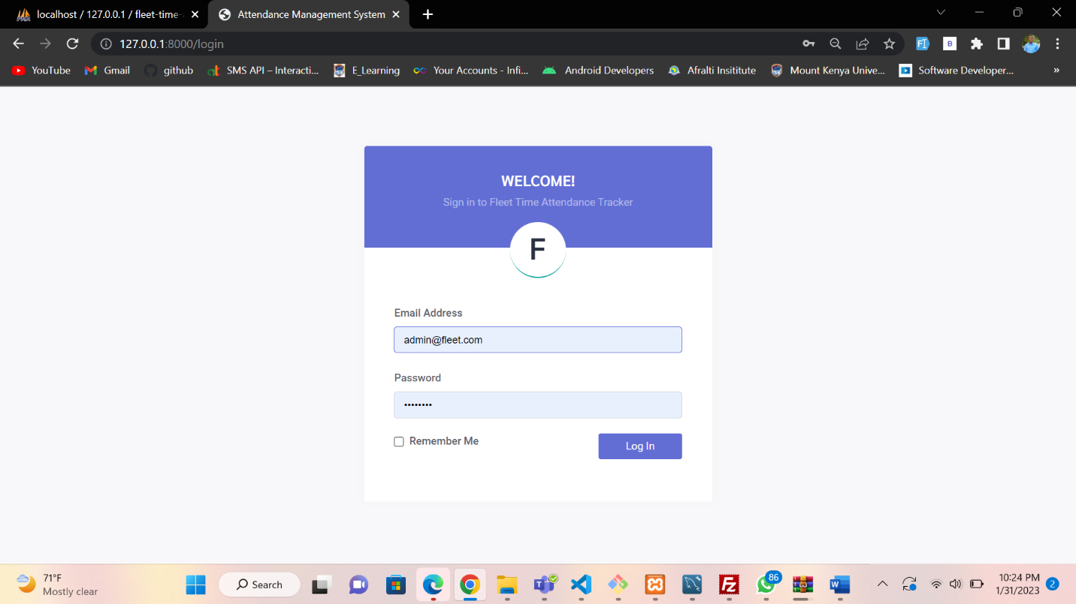

**Logged in as Admin.**

Dashboard View

Show;

Total Employees in the company  
Total Job Position created in the company  
Total Duty stations in the company.  
Total Vehicles in the company.

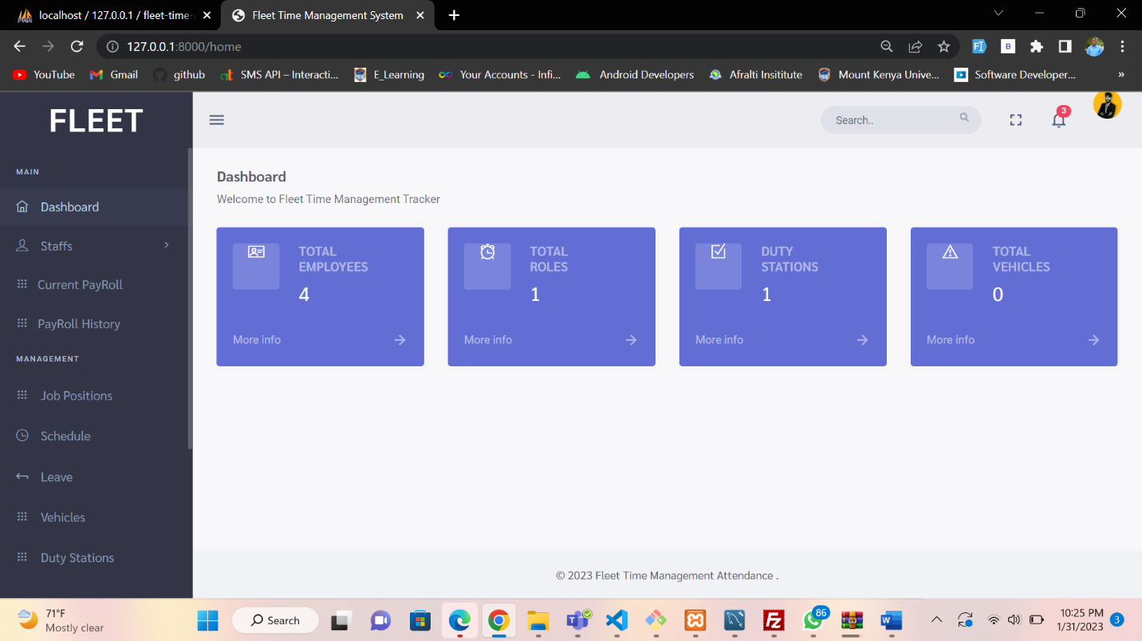

Modules available for Super Admin

1. Staffs
2. Payroll
3. Job Positions
4. Schedule (Clock in Attendance)
5. Leave
6. Vehicles
7. Duty Stations
8. User management

Staffs

Divided into three;

* General Staffs data

* Employees Logs-> New Employees payroll is being updated.

This tab shows the new employee whose data has not been captured into the company’s payroll, the clerk or person in-charge clicks on the update button to update it into the payroll, it’s a one time activity for the new staffs and done at the end of the 1st month for the new employee.

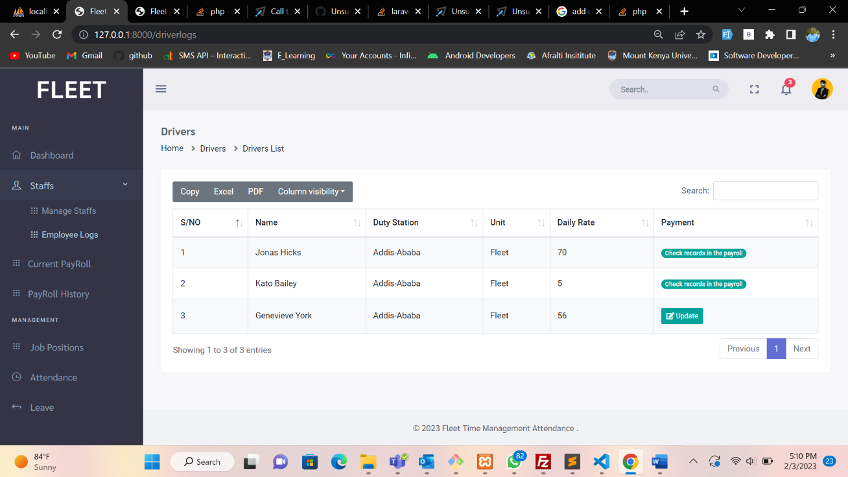

Payroll

Divided into 2, current and previous payroll data.

Current payroll shows the payroll of that specific month running from date 24th to date 23rd of every month.

You can only update the payroll just ones a month.

On the payroll window, one can also filter with payroll batches and/or search specific employee name

Example for the batch filter

If you click on update it will ask you the payroll batch you want to update

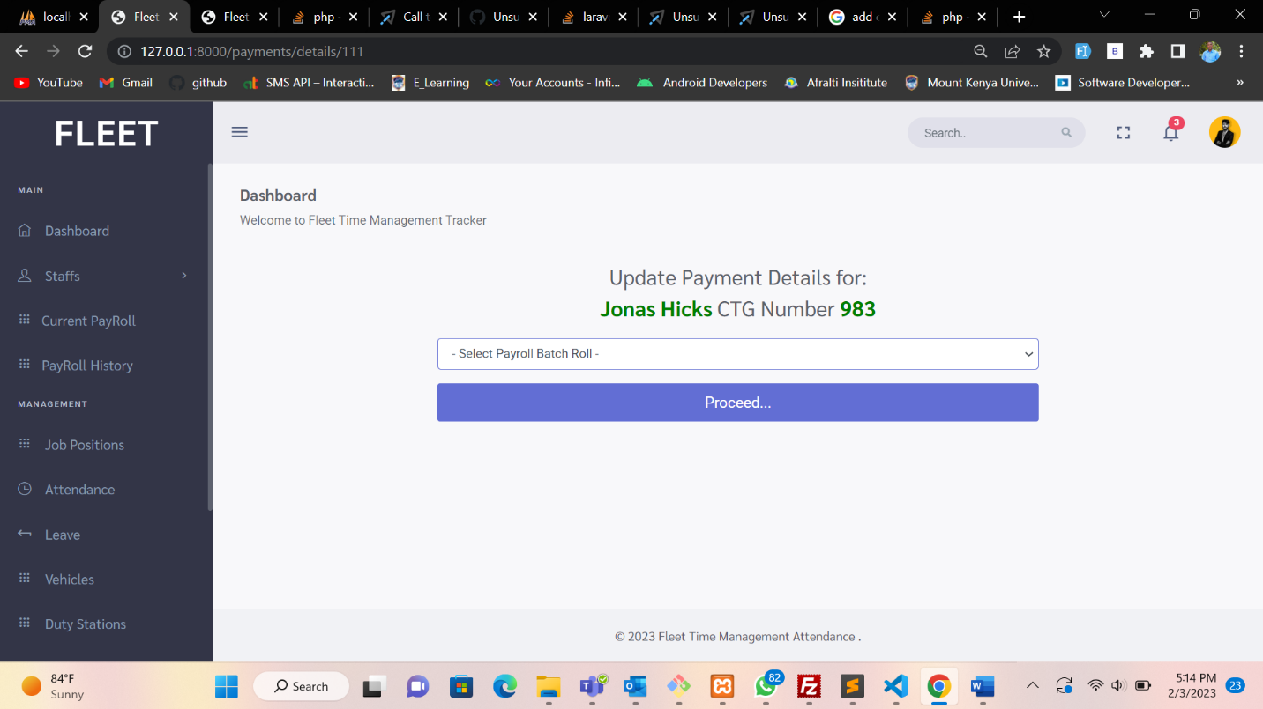

If the payroll batch has been rolled out, it will return a message as shown and allows you to wait until the following month.

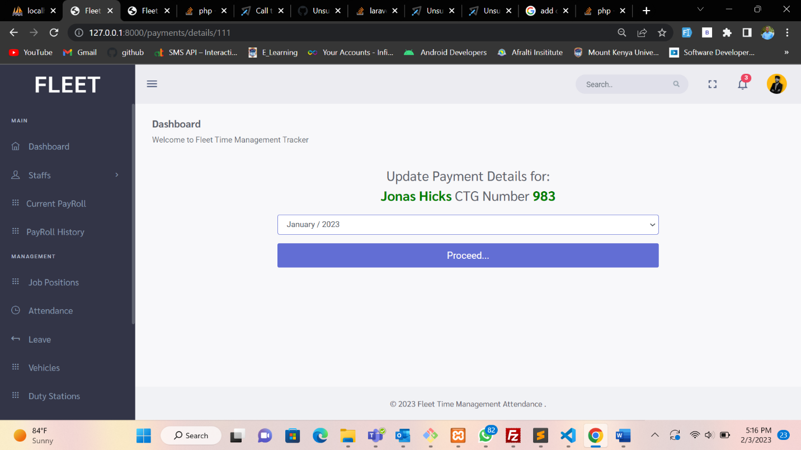

Job Position

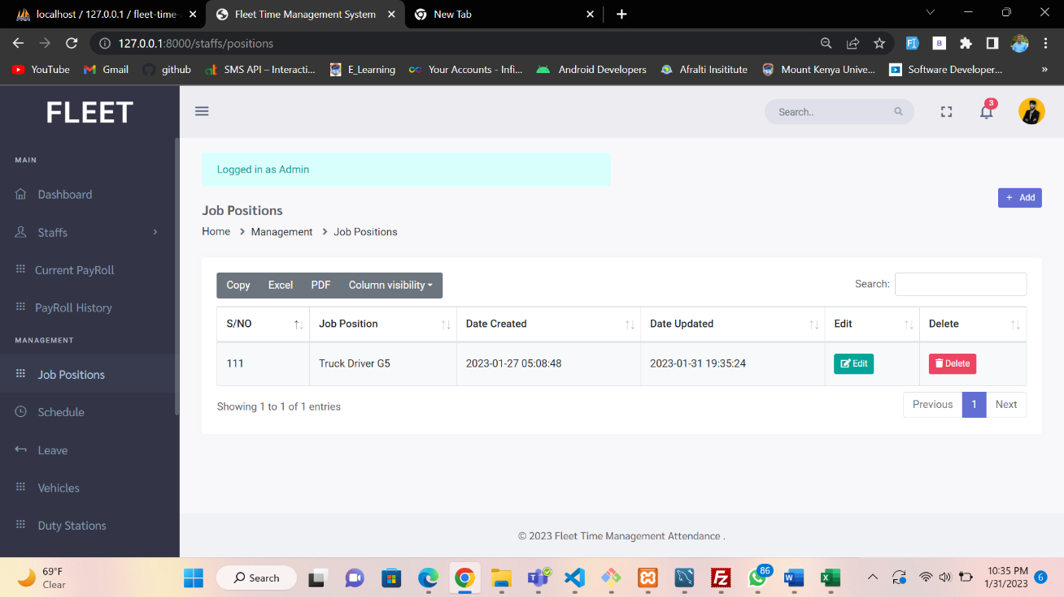

Admin can add new job positions, edit or remove as show on the screenshot

Schedule (Clock in Attendance)

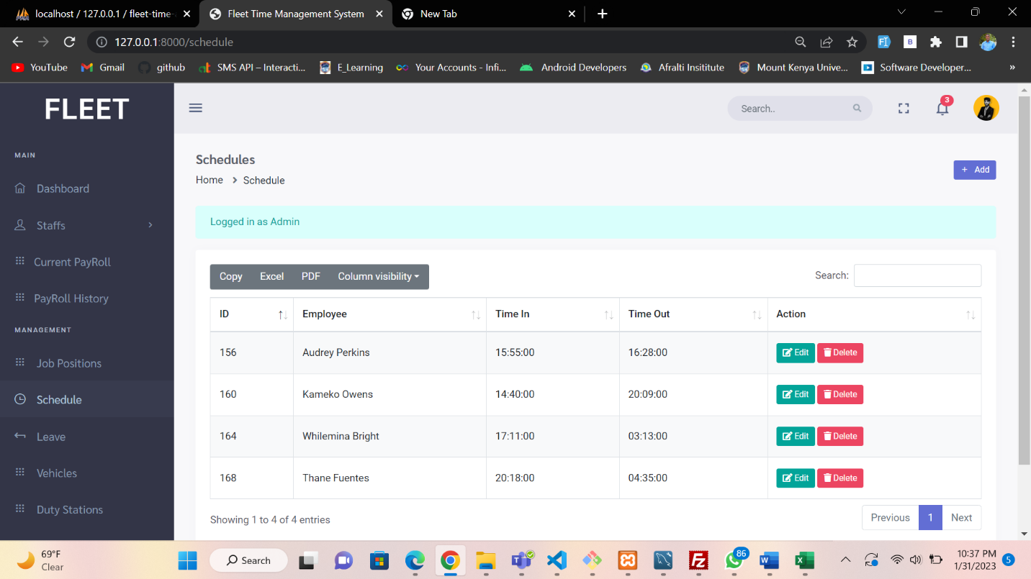

Attendance are being clocked in daily and ones per day by the clerk

Total number of days clocked every end of a monthly circle are used in calculation of the payroll.

Details captured during clock in are as per the screenshot below

**Note: You can only clock in an employee ones a day**

Leave

Clerk or admin update the leave days for the employees, leave captured are annual or sick leave.

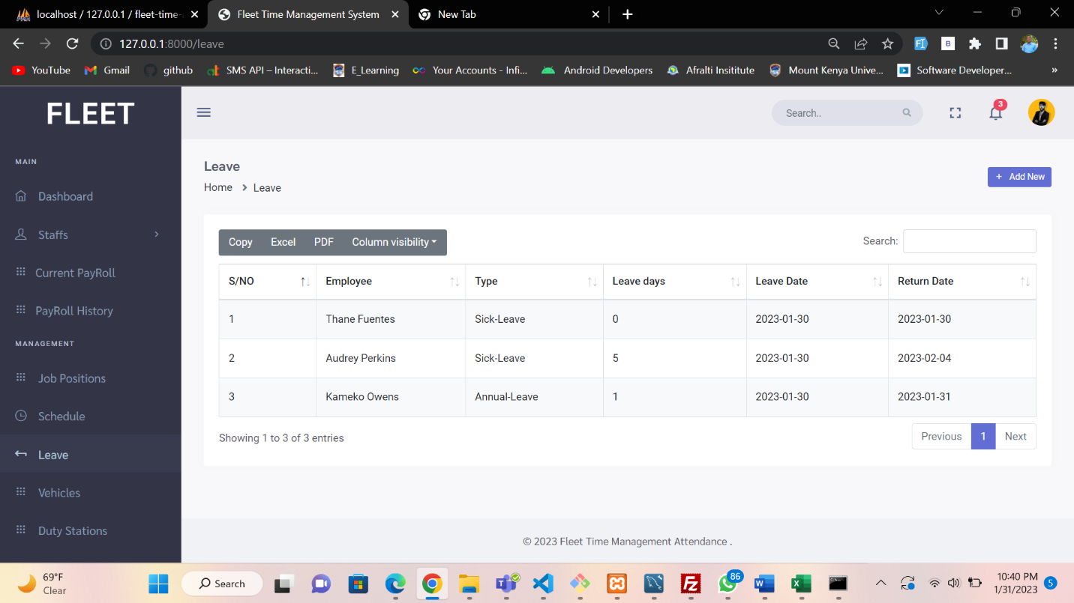

Details captured on the leave entry are show by the screenshot below.

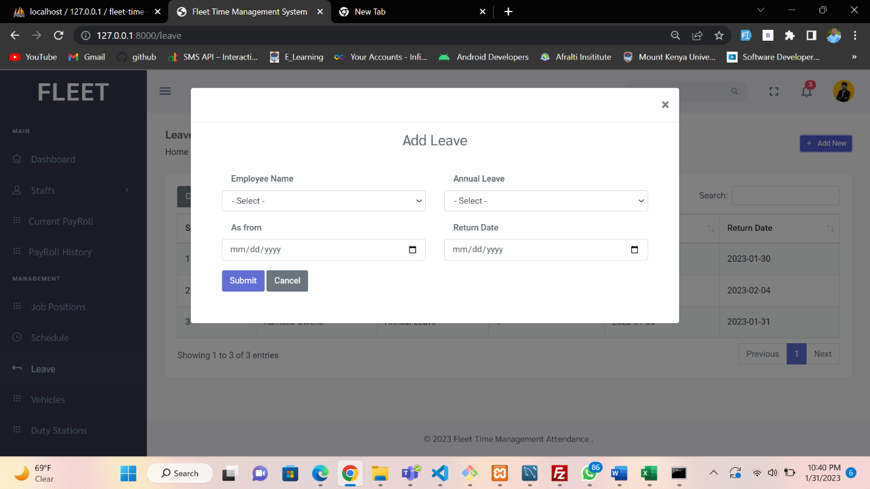

Vehicles

You can add new trucks/vehicles in the company on the system and assign each driver a specific truck, thus helping in tracking the employees

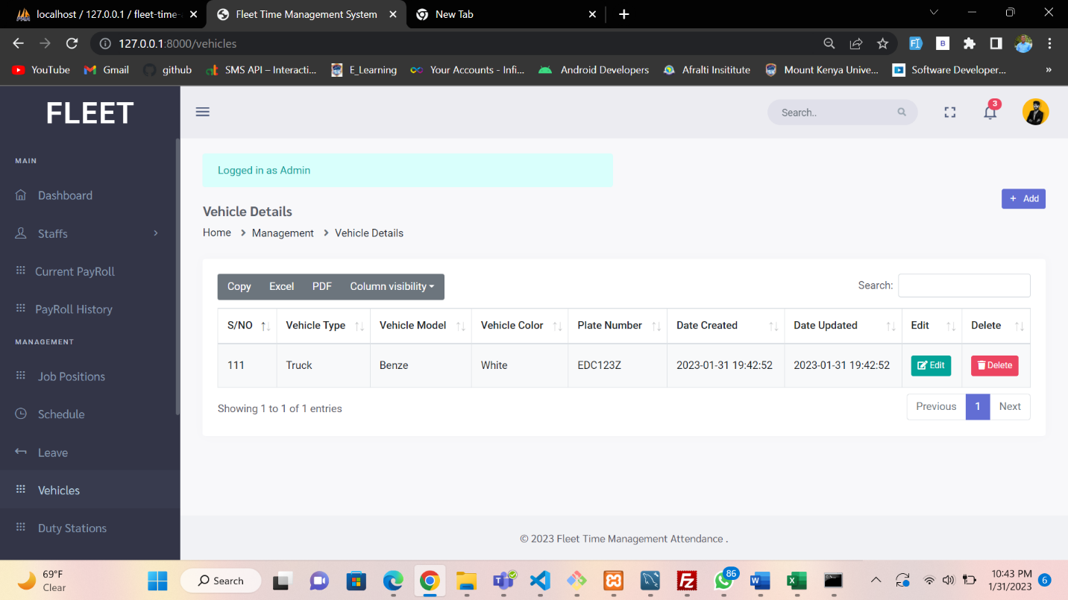

Duty Stations

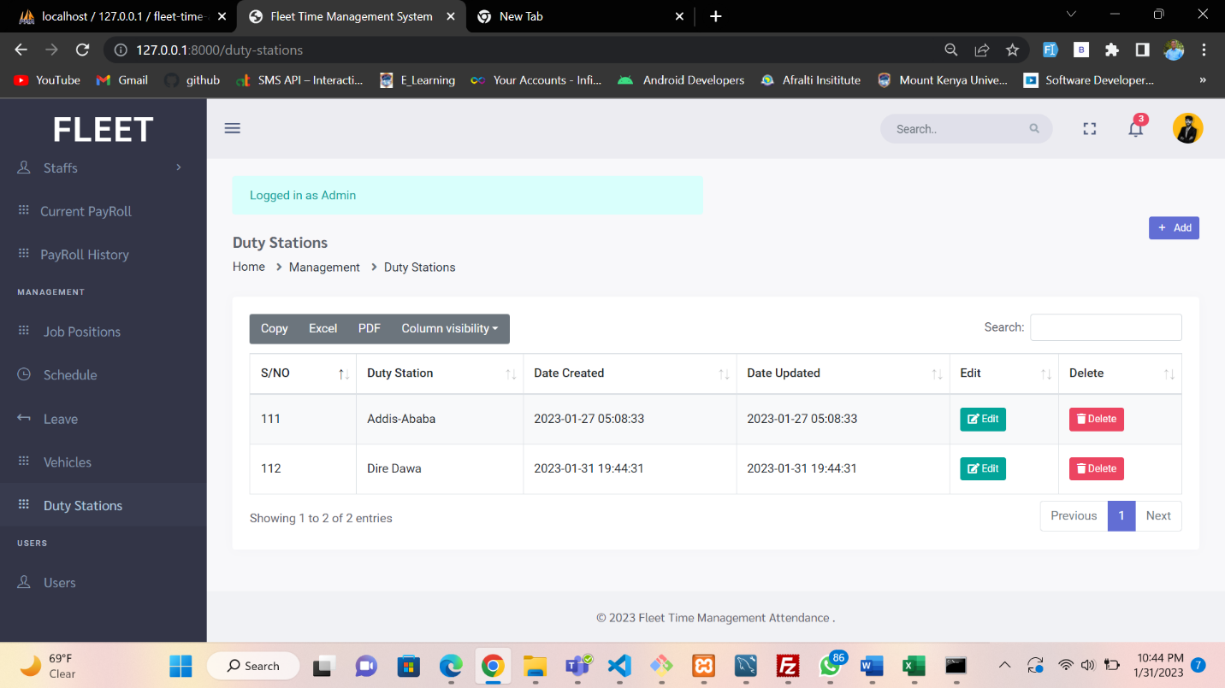

User management

Admin can manage other users by either block, create, or edit a user.

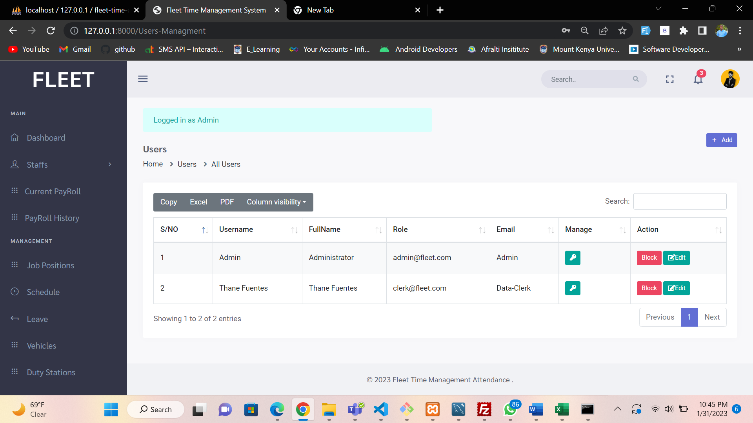

**Logged in as Clerk.**

Noted: Clerks only enter the days attendances and leaves, no special privileges given

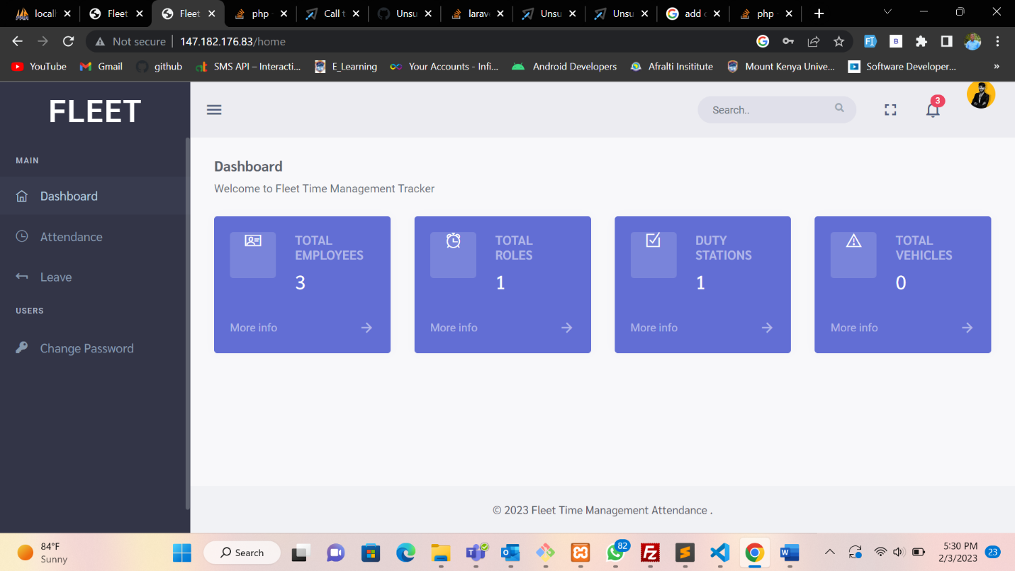

Attendance Tab

Works the same as admin except, no edit or delete button as shown.

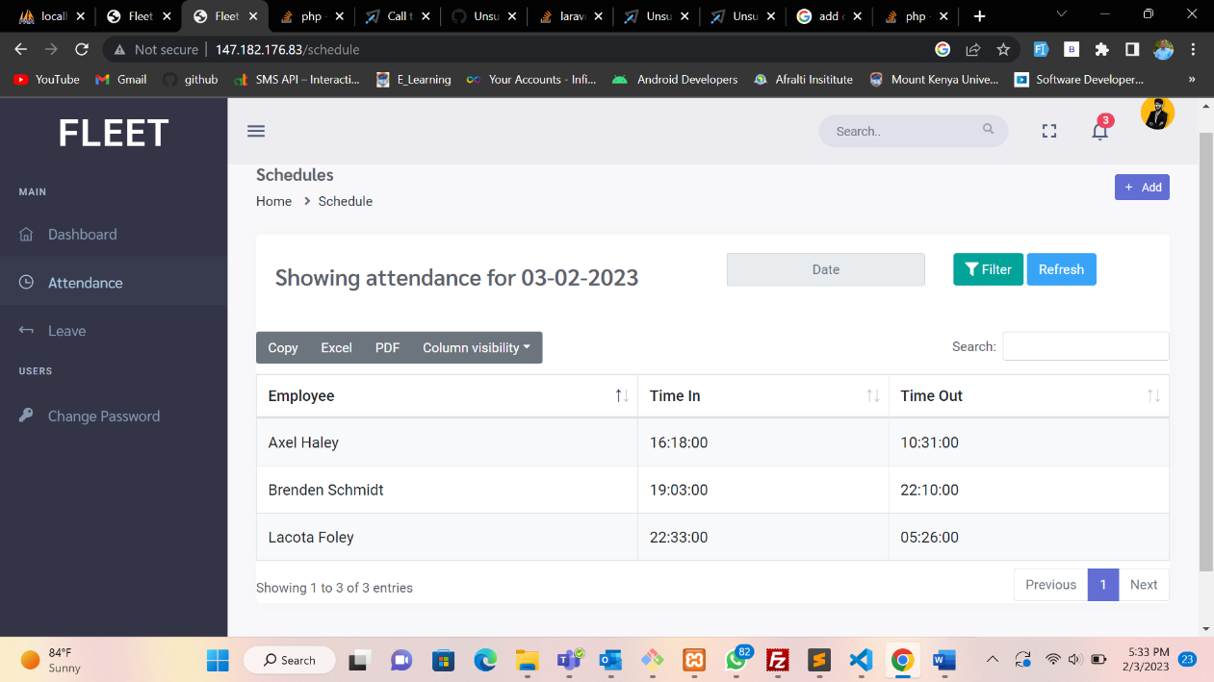

Leave tab.

Also functions the same as admin, with no privileges.

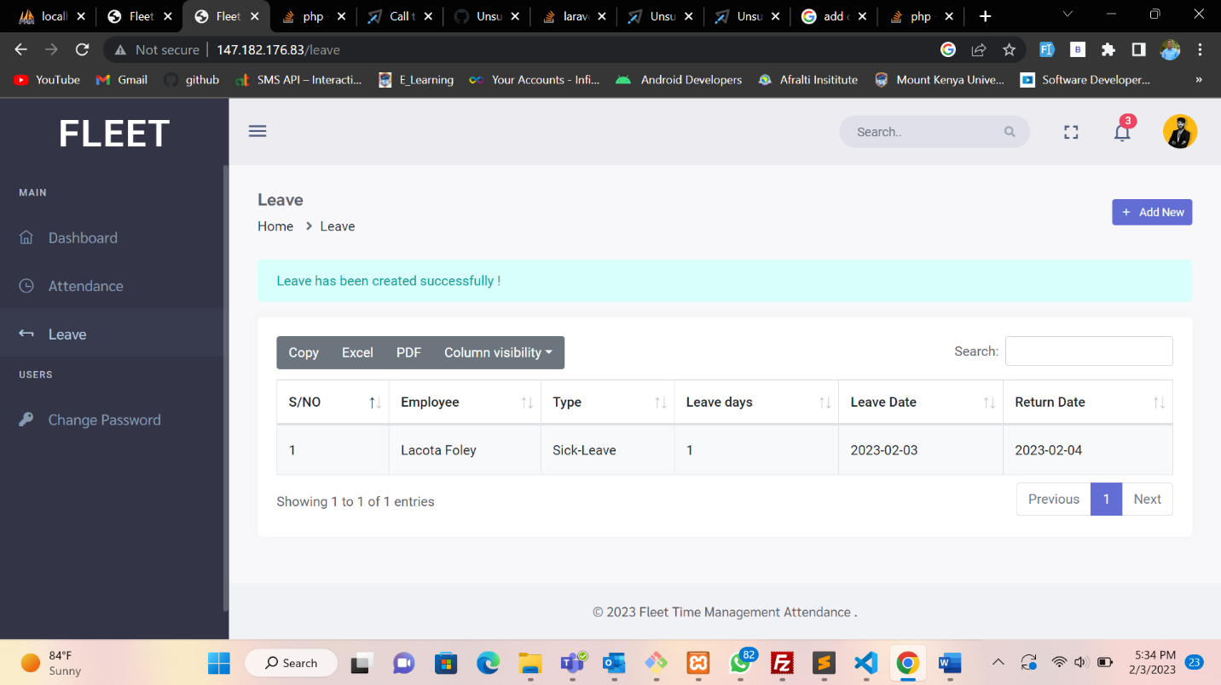

And lastly on the clerks, they can change their passwords on the tab below (Change Password)

**Logged in as Duty Station In-charge.**

Dashboard.

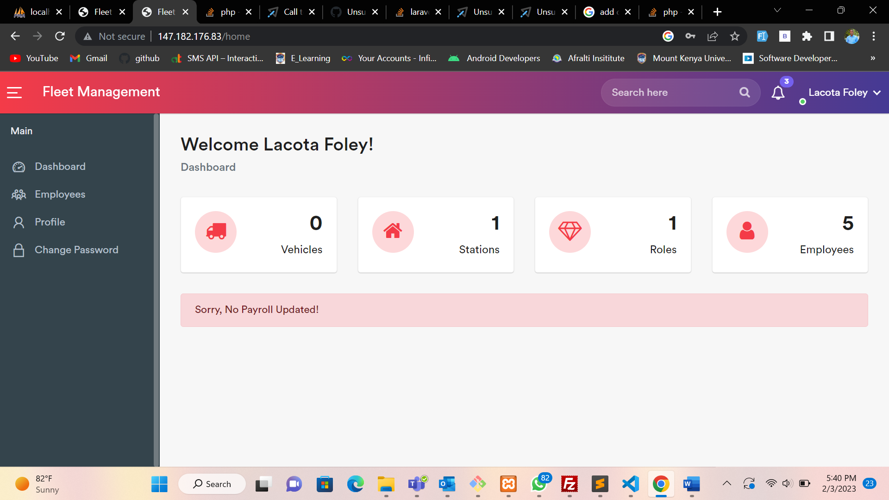

Shows a summary of the company, no sensitive data shown here.

Employees Tab

Shows employees falling under that specific duty station.

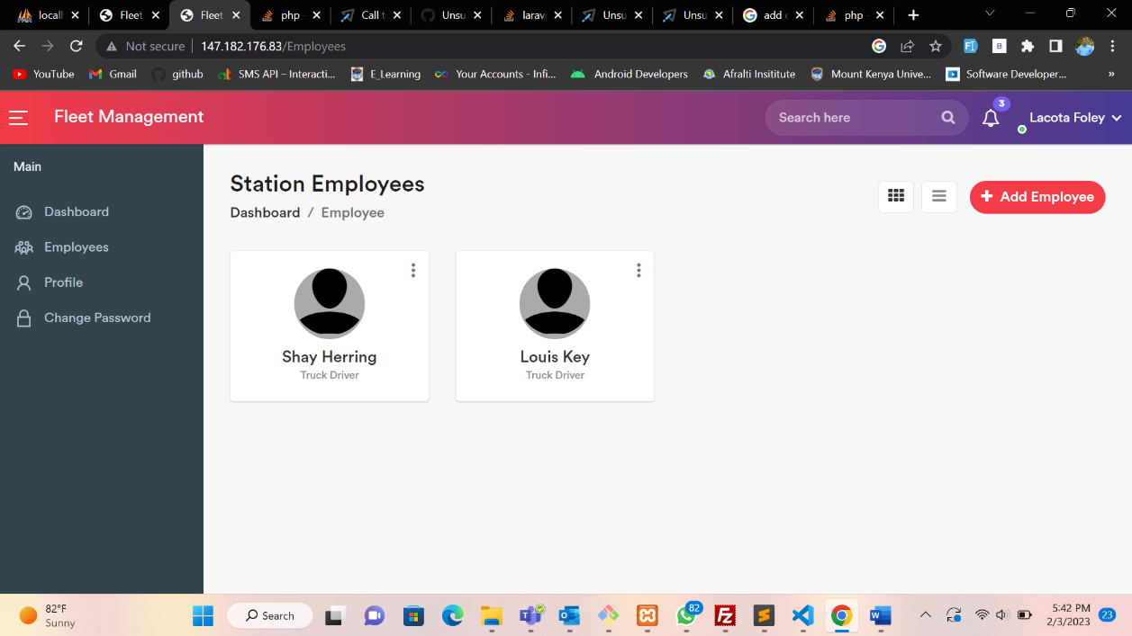

Lastly we have profile and change password



